Chula Vista Elementary School District

Olympic View Elementary School Home of the Golden Eagles

2026 - 2027

Parent and Student Handbook



Board of Education
Lucy Ugarte• Francisco Tamayo
Jessica R Tolston • Delia Dominguez Cervates • Keren Ramirez Dominquez

Superintendent
Eduardo Reyes, Ed.D.
http://www.cvesd.org

All students and staff of public primary, elementary, junior high, and senior high schools have the inalienable right to attend campuses that are safe, secure, and peaceful.

California Constitution
Article I, § 28 (c)

EQUAL OPPORTUNITY EMPLOYER
The Chula Vista Elementary School District is committed to providing equal educational, contracting, and employment opportunity to all in strict compliance with all applicable state and federal laws and regulations. The District office that monitors compliance is the Human Resources Services and Support Office, 84 East J Street, Chula Vista, CA 91910, phone 619-425-9600, ext. 1340. Any individual who believes s/he has been a victim of unlawful discrimination in employment, contracting, or in an educational program may file a formal complaint with the District’s Human Resources Office.

Olympic View Elementary School
Parent Information Handbook Index

Welcome Letter from Mrs. Lisa Lines, Principal --------------------------------------------------------------------1

Vision Statement -----------------------------------------------------------------------------------------------------------2

School Information ---------------------------------------------------------------------------------------------------------3-8

School/Office/Gate Hours ---------------------------------------------------------------------------------------------3
Emergency Information-------------------------------------------------------------------------------------------------3
Class Assignments -----------------------------------------------------------------------------------------------------4
Telephone Calls/Cell Phones ----------------------------------------------------------------------------------------4
Breakfast/Lunch ---------------------------------------------------------------------------------------------------------4
Uniforms and Dress Guidelines -------------------------------------------------------------------------------------5-6
Tardiness/Attendance Policy -----------------------------------------------------------------------------------------7
Soft Absences ------------------------------------------------------------------------------------------------------------8-9
Chronic Absence --------------------------------------------------------------------------------------------------------10
Truancy --------------------------------------------------------------------------------------------------------------------10
Medication ----------------------------------------------------------------------------------------------------------------10
Safety ----------------------------------------------------------------------------------------------------------------------11
If You Move --------------------------------------------------------------------------------------------------------------11
Visitors/Volunteers -----------------------------------------------------------------------------------------------------11
Childcare Programs----------------------------------------------------------------------------------------------------11
Blog/Website ------------------------------------------------------------------------------------------------------------11

Students Rights and Responsibilities --------------------------------------------------------------------------------12-14

Bullying Policy -------------------------------------------------------------------------------------------------------------14-15

Parent Involvement Policy----------------------------------------------------------------------------------------------16-17

Parent Involvement Policy – Student/School/Parent Compact -----------------------------------------------18-19

The OV WAY! --------------------------------------------------------------------------------------------------------------20

OV Character Traits ------------------------------------------------------------------------------------------------------21

Staff Roster -----------------------------------------------------------------------------------------------------------------22

Daily Schedule -------------------------------------------------------------------------------------------------------------23

Campus Map ---------------------------------------------------------------------------------------------------------------24

2025-26 School Calendar --------------------------------------------------------------------------------------------25-26

OLYMPIC VIEW ELEMENTARY
1220 South Greensview Dr., Chula Vista, CA 91915 (619)656-2030 FAX: (619) 619-656-8752
Mrs. Lisa Lines, Principal
www.olympicviewgoldeneagles.org_

“Olympic View Golden Eagles BELONG, LEARN, and LEAD to SUCCEED!”


July 2026
Dear Olympic View Families and Friends
Welcome to the 2026-27 school year! The Olympic View Staff is excited to welcome ALL our students back to campus on July 22! We are proud to be in our 8th year as a Leader in Me School. Leader in Me is a whole-school improvement process based on the idea that everyone can be a leader. This evidence-based approach empowers students with the leadership and life-skills they need to thrive in the 21st century.
What can you expect in our 8th year as a Leader in Me School? Our students will continue to focus on the power of service-learning and building trust amongst peers. We will also be doing more family outreach this year. Visit the Leader in Me Blog for inspiration and resources or learn more at www.leaderinme.org

We focus on the academic, social, emotional, and physical well-being of students. At Olympic View, we capitalize on your child's inquisitiveness and desire to learn. We guide and provide your child with the knowledge and skills necessary to be a successful, productive member of society. It is our goal to provide the most relevant, equitable, inclusive, responsible, and ethical environment for ALL.
Our mission statement: “Olympic View Golden Eagles BELONG, LEARN and LEAD to SUCCEED is inclusive to all. Working together, you as your child's first teacher, the staff, students, and I will have a rewarding year filled with learning, lifelong relationships, and the joys of success and accomplishment. I am looking forward to working with you and your children. My door is always open, and I am always available to you.
Stay Golden!
Lisa Lines, Principal

1



OLYMPIC VIEW VISION STATEMENT

The Olympic View Community believes; 1). Everyone can be a leader 2). Everyone has genius 3). Change begins with me 4). We can empower students to lead their own learning 5). Educators and families partner to develop the whole person. Our children are at the center of all of decisions. Olympic View Elementary School provides a rigorous, well-balanced education preparing students for the 21st century.

We value the development of the whole child. At Olympic View, students reach their highest potential intellectually, physically, emotionally, and socially. Building on a strong foundation of academics, students acquire the skills necessary to be literate, constructive, and contributing citizens.

Olympic View students are prepared to compete in a technologically advanced world. They value inclusiveness, respect, and diversity. Upon leaving Olympic View, students are responsible, resilient, life-long learners. Students appreciate Olympic View as an essential building block in their professional and personal lives.

Our entire community embodies the Olympic Spirit by modeling positive human relations. Families, students, staff, community, and businesses work together to make decisions while accepting the responsibility for the success of our children. We ensure a safe environment in which all individuals have a sense of belonging and everyone is treated with dignity and respect.

Olympic View serves as a center where activities and programs enrich the entire community in the areas of fine arts, academics, technology, and physical well-being.

Our Mission Statement: Olympic View Golden Eagles BELONG, LEARN, and LEAD to SUCCEED!

Olympic View Goals

- Deliver a rigorous Common Core standards-based curriculum in a safe, nurturing environment.
- Provide differentiated instruction based on students’ strengths and needs.
- Integrate technology into the curriculum as a tool for learning.
- Develop responsible, resilient life-long learners.

2

SCHOOL HOURS:
Children should not arrive at school before 7:45 a.m. They should be lined up on the blacktop no later than 8:15 a.m. The warning bell rings at 8:13. The gates will be closed at 8:16 am

TK/Kindergarten 8:15 a.m. – 2:30 p.m. (Friday Dismissal: 1:00 p.m.)

Grades 1 -6 8:15 a.m. – 2:45 p.m. (Friday Dismissal: 1:15 p.m.)
AM Pre k 8:30 am – 11:30 pm
PM Pre K 12:30 – 3:30 pm

Please do not leave your children unattended on the school grounds before or after school as there is not before or after school supervision. If you need after-school care for your child please consider the Character Builders “YMCA” , LEAD HUB or other available programs. Unless they participate in Character Builders “YMCA” , LEAD HUB, or are enrolled in a structured, after-school activities, students are to be picked up within 15 minutes of dismissal or walk home immediately. Those not picked up must sign at the office and checked out by a parent or person on the emergency list.

OFFICE HOURS:
The school office is open from 7:45 a.m. to 4:00 p.m. Monday through Friday. The school telephone number is 619-656-2030 and the fax number is 619-656-8752.

The gates will be locked according to the following schedule:

The gates will be locked:
Monday-Thursday: 8:16 a.m.-2:45 p.m.
4:00 p.m.-7:30 a.m.
Friday: 8:16 a.m.-1:15 p.m.

The gate at the top of the stairs next to the church leading up to the campus will be locked:
Monday-Thursday: 8:20 a.m.-2:45 p.m.
4:00 p.m.-7:30 a.m.
Friday: 8:20 a.m.-1:15 p.m.

The YMCA hours:
Monday-Friday: 6:00 a.m.-7:45 a.m.
3:00 p.m.-6:00 p.m.
The LEAD HUB hours:
Monday-Friday: 3:00 p.m.-5:15 p.m.

Gates will be locked at all times on weekends, school holidays and when school is off session.

Access to the campus during school hours is through the main office. Visitors and volunteers provide a picture ID, must sign in on the computer (Raptor) and wear a 'Visitor' or 'Volunteer' badge while on campus.

EMERGENCY INFORMATION:
It is very important that you keep all emergency information up to date with the school office. If your email, phone number, or emergency contacts have changed since you have registered, please be sure to contact the school office to make sure the information gets updated in our system.

Students will not be released to anyone who is not an emergency contact. If you have an emergency contact picking up your child, please let them know they will be asked to show ID. This is for the sole purpose of safety. Parents/guardians who are not familiar to the office staff will also be asked to show ID. Again, your child(ren)’s safety is our number one priority.

3

CLASS ASSIGNMENTS:
Each year we are often faced with the task of moving a few children from one classroom to another in order to correct an imbalance in class composition. Typically, these changes occur within the first two weeks of school, but changes may occur at any time during the school year. We strive to keep these changes to a bare minimum; however, it is hard to predict exact growth patterns and which grade levels will be affected. In the event changes do become necessary, we hope that we may count on your cooperation and understanding. At the beginning of the school year, we would like to ask families to please wait until the third week of school to discuss any possible class assignment change. If a family wishes to talk about a possible change, they need to pick up a form from the office describing the rationale for the change. An appointment with the principal will be arranged to discuss the request and to consider all factors associated with a possible change in placement.

TELEPHONE CALLS/CELL PHONES:
It is very disruptive to call a child to the telephone during the instructional day, so please do not ask the office staff to do so. If you must leave a message for your child, you may either leave a voice mail or a message with the office secretaries, but please do not abuse the privilege. Prior to coming to school each day, make sure your child knows where to go after school. Phone use by students is restricted to emergencies only. Students will not be allowed to use the school telephone to alter after school plans. All teachers use Class DOJO for communication, and you can contact your child’s teacher that way as well.

A student may have a cell phone/smart watch with cell service on campus only if the parent/guardian has filled out and submitted a Cell Phone Permission form electronically. A student may bring a cell phone only after the parent has completed this form. Cell phone permission approval is valid for one school year only and must be renewed each school year. On campus violation listed in Cell Phone Permission form could result in the revocation of cell phone privileges. If a child’s phone is confiscated due to use violation, a parent/guardian must come to the office to pick up the phone from an administrator.

BREAKFAST AND LUNCH:
Meals will be free for all students for the 26-27 school year. We ask that ALL parents fill out the LCFF form as soon as possible. Our school funding is based on the number of forms returned. If your child brings lunch to school, please be sure to remind them there may not be any sharing of food. Please be mindful that we have many students with allergies.

If you come on campus to eat lunch with your child, you must have approval from Principal. This should only occur on special occasions. Please note, we have a designated guest table at which you can sit with your child. You may not provide food for children other than your own. We ask that you do not enter the playground area with the students during recess. You also must be cleared through the Raptor system and check in at the front office for a badge.

Please send healthy snacks and lunch to school with your children. Do not send sodas, candy, chips, or gum. All children must eat lunch every day. Olympic View is a GUM FREE CAMPUS.

CVESD Board Policy 5030: WELLNESS
“No celebratory food items will be allowed on school sites during the school day in celebration of a student’s birthday. The district encourages and supports the use of nonfood celebratory activities and will provide a list of suggestions to schools and parents.” Helium Balloons are not allowed on campus.

4

UNIFORMS AND DRESS GUIDELINES:
Uniforms are encouraged at Olympic View. Your support of and commitment to the uniform policy is vital to its success! We believe it sets high standards for the students by:
  - reducing peer pressure
  - increasing safety and security
  - eliminating the wearing of inappropriate clothing items
  - improving personal responsibility and accountability
  - preparing for the workplace
  - reinforcing positive behavior
  - allowing students to focus on academic targets

Uniforms support our school spirit and a sense of esprit de corp. Our goal is to keep our focus on academic and social growth, not on the latest fashion trends. We see school uniforms as one positive and creative way to reduce discipline problems and increase school safety. Students who feel safe and secure learn basic values, the essentials of good citizenship, and are better students.

The school uniform consists of the following: solid Navy blue or Khaki pants, shorts, skirts or jumpers, and solid red, white, or navy-blue shirts. If you require assistance acquiring the uniforms, please contact the office. Information is confidential.

School Spirit shirts can be worn on any day of the school week.

If you choose NOT to have your child wear a school uniform, the district dress policy must be followed:

Students are expected to come to school appropriately dressed. Students failing to dress appropriately will be asked to change. If students are unable to change, parents/guardians will be contacted to bring clothing for their child to school. Parents/guardians are encouraged to have all student clothing free of any writing, pictures, or insignias. Students are not allowed to display by wearing or placement of apparel which would signify the affiliation or intent of affiliation in a student group advocating or participating in disruptive behavior. Ed Code 35183

Olympic View allows for the outdoor use of sun-protective clothing and the use of sunscreen by students during the day. Sun Protective Clothing EC 35183.5

PANTS SHOULD:
- Be fitted at the waist
- Be worn on the waist, not sagging
- Stay up on the waist if the belt isn’t worn
- Completely cover other clothing worn as an undergarment (gym shorts, underwear, etc.)
- Leggings must be worn appropriately

SHORTS SHOULD:
- Be fitted at the waist
- Be long enough to cover buttocks, upper thighs when walking, sitting, bending or reaching
- Not be torn

SKIRTS, SKORTS, DRESSES SHOULD:
- Be long enough to cover buttocks, upper thighs when walking, sitting, bending or reaching

5

TOPS SHOULD:
- Not be backless, low back or low front
- Not be tube tops, halter tops, or spaghetti straps
- Not show bra, bandeau, or bra-like items
- Be long enough so that skin is not showing at midriff when arms are raised
- Clothes shall be sufficient to conceal undergarments at all times

SHOES SHOULD:
- Be worn at all times and tied
- Cover heels and toes
- Tennis shoes must be tied at all times
- Sandals must have closed toes and closed heels
- Flip-flops or other backless shoes or sandals are not acceptable and can create a safety issue

NOT ALLOWED ON CLOTHING OR ACCESSORIES:
- Hanging belts, belts must be through belts loops
- Hairnets, bandanas, or blankets worn as outer garment covering
- Pajamas (only during class and school spirit days)
- Clothing with words or logos shall be free of writing or images that promote alcohol, tobacco, drugs, gangs, violence, profanity, rude, pictures, vulgarity, sexual connotations
or racial prejudice
- Any item that becomes a disruption to the educational process
- Make-up is inappropriate in the elementary school
- Dangling earrings, long chains, and keys are worn visibly around the neck are unsafe (key chains should not be on the playground, as it will present a danger).
- False nails pose a safety risk during PE and recess and may not be worn. Students also have a difficult time typing with false nails.

Students may not wear clothing, jewelry, or personal items that:
- Are pornographic, contain threats, or that promote illegal or violent conduct such as the unlawful use of drugs, tobacco, or drug paraphernalia.
- Demonstrate hate group associations/affiliation and or use hate speech targeting groups based on race, ethnicity, gender, sexual orientation, gender, religious affiliation, or other protected groups.
- Cover the student’s face to the extent that the student is not identifiable (except clothing/headgear worn for religious or medical purpose).
- Or demonstrate gang affiliation.
Attire worn in observance of a student’s religion are not subject to the policy.

6

TARDINESS/ATTENDANCE Policy
Under California Law (Ed. Code 48200) parents and guardians are charged with
the responsibility of keeping their children in regular attendance and on time

Olympic View Elementary School will only excuse an absence for the following reasons:
  - Illness
  - Medical or dental appointment
  - Quarantine by a county or city health officer
  - Funeral of immediate family member (Grandparent, parent, or sibling)
  - Military parent leaving for or returning from deployment

ATTENDANCE:

School attendance is critical for learning.
  - If your child is absent:
- Call the Attendance line on the day of the absence, or send a note the first day back to
school. To reach the Attendance line, dial 656-2030 and select #2 on the menu. Leave a message regarding your child’s absence for our school Attendance/Health Secretary. If your child is absent three days or more, a doctor’s note is helpful. Parent/guardian has three days, (72 hours), after an absence, late arrival or early dismissal to submit a doctor/dentist note or it is considered a truancy. Reporting the absence does not automatically excuse the absence.

The reason given for the absence determines whether the absence is excused or unexcused. Failure to provide a reason makes the absence unexcused.
- If your child will be absent for religious reasons, to participate in “Take Your Child to Work
Day”, to attend a military function for a parent, etc.:
- A written request stating the reason for the absence must be presented to the school Attendance office for Principal approval two days prior to the absence. If approved, the absence becomes a “Board Justified” absence. If the absence is not approved, it is an unexcused absence.

- To sign a child out before dismissal:
- Please do not pick up your child early unless she/he has a medical or dental appointment. School District policy requires that any child signed out thirty minutes or more before dismissal time is considered an unexcused absence unless the reason is for a doctor or dental appointment. A doctor’s note verifying the appointment is required when the child returns to school, otherwise, the absence will be considered unexcused. This does not apply when a child is signed out to go home due to illness nor is a note required from a doctor when they return to school.

- Independent Study Contract:
- An Independent Study Contract can be obtained for a child who will be absent five or
more days.
- The parent must notify the teacher of the absence and discuss the Independent Study
Contract at least one week prior to the start of the absence.
- The parent must also notify the Attendance office of the absence and request the
Independent Study Contract at least one week prior to the start of the absence.
- An Independent Study Contract must be signed prior to the start of the absence.
- (PLEASE NOTE THIS IS SUBJECT TO CHANGE DUE TO COVID)

Children should not be absent except for medical reasons. Please schedule vacations during school breaks. Students learn when they are in school.

To be eligible for Perfect Attendance, the student must be in class on time and must stay in class the entire day every day that school is in session. (i.e., the student cannot be late too school for any reason or be taken out of school early for any reason or be absent from school for any reason.)
7

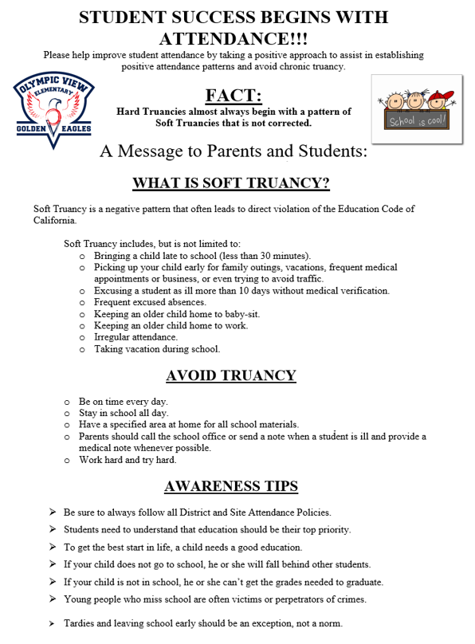

8
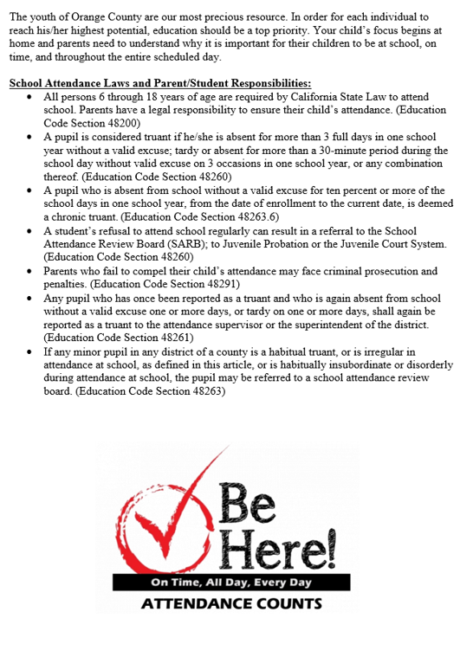

9

CHRONIC ABSENCE:
Recently, there has been a growing interest regarding attendance data and the impact this has on student success. Now as part of Every Student Succeeds Act (ESSA, Section 111(h)(1)(C)(viii)), districts are required to submit chronic absenteeism data through the California Department of Education’s California Longitudinal Pupil Achievement Data System (CALPADS). Students are identified as chronically absent when they have missed 10% or more days for both excused and unexcused absences in relation to the total days enrolled for any given school year.

In an effort to partner with parent(s)/guardian(s) regarding chronically absent students, schools may request information as to why students are missing so many days of excused and/or unexcused absences. School nurses may ask parent(s)/guardian(s) to sign a release of information for the students’ attending physician in an effort to best support the students’ medical needs at school to the extent possible.

Additionally, parent(s)/guardian(s) and students may be placed on a Student Attendance Review Team (SART) contract as a means of intervention to support positive attendance.

If attendance continues to be irregular, the student may be referred to the School Attendance Review Board (SARB). See “Truancy” information below.

State definition = Missing 10% of school with both excused and unexcused absences.
- Any point in time

Quarterly reports provided
- Tool to guide conversations
- Excused with doctor notes cannot be included in conversation

Does not address tardies

*Excessive Dr. Notes – involve Nurse
- May need authorization form by parent

TRUANCY:
State law requires that elementary school attendance is compulsory. Parents/guardians are responsible for making sure that their children attend school every day, on time. Students with more than three unexcused absences in one school year shall be classified as truant. Students who are more than 30 minutes tardy, or who are signed out more than 30 minutes early on three or more school days in one school year shall be classified as truant (Education Code 48260). Such students shall be reported to the principal. The parent/guardian shall be notified of the student’s truancy by a letter from the principal. If necessary, a parent/guardian conference will be arranged to address the truancy. Students reported as truant three or more times during the year may be classified as habitually truant and referred to the Student Attendance Review Board (SARB). (Education Code 48263)

MEDICATION:
If your child must take any medication at school, we must have a form signed by your physician each year, and the medication must be kept in the health room. Discontinuation of medication and changes in dosage or time require written instruction from the physician. This applies to prescription and non-prescription medicine. Every time your child is on a medication for a specific illness such as strep throat, bronchitis, pink eye, etc., a new form must accompany the prescription. Contact the Health Office at 619-656-2030 for the proper medication form.

10

SAFETY:
We would like to ask the adults, in addition to the children, to abide by Safety Patrol Rules. If your child sees you waiting for the Safety Patrol, your child will follow suit. Please help us in preventing jaywalking. Encourage your student to follow safety guidelines. Please do not park in any of the red areas. This is a no parking area, and you will be ticketed. Also, do not leave your car unattended in the yellow zone. Students in PK and K will be picked up at the PK and Kinder gates. Grades 1-3 should be picked up in the north pick up, and grades 4-6 in the bus loop. If you have more than one child, pick up should occur at the youngest child’s pick-up spot Children should not cross parking lot to get to his/her car. Students should enter and exit car on the passenger side in the drop off/pick up lane. Please do not park in any parking spaces that are designated for staff. Thank you for being polite to other drivers, our staff and volunteers, and the student Safety Patrol, as our children learn from the behaviors that we model.

IF YOU MOVE:
If you move at any time during the school year, you must complete the following steps within two weeks of the move:
  - Verify residency with your new address.
  - Update the Green emergency forms in the Health Office with your new address
and any other information that has changed.
  - If you have moved out of the Olympic View boundaries, it will be necessary to fill
out a Zone Transfer so that your student(s) can finish the remainder of the
school year at Olympic View.

VISITORS/VOLUNTEERS:
All visitors and volunteers must check in at the school office using Raptor APP or Driver’s License A visitor or volunteer badge will be provided and must be visibly always worn while you are on campus. All volunteers must attend the volunteer training conducted by the principal, or also available on-line. There are no volunteers on campus the first two weeks of school, and teachers have the discretion as to how many and how often they need volunteers.

CHILD CARE PROGRAMS:
Character Builders “YMCA”: Before and after school childcare from 6:00 a.m. – 6:00 p.m. Character Builders “YMCA” childcare is located on our campus in room 803. Their telephone number is 619-421-8805.

LEAD HUB: The ‘Dynamic After School Hours’ program is conducted by the Character Builders “YMCA” on the Olympic View school grounds. This free program provides structured after school activities for 1st-6th grade children. It operates Monday through Thursday from 2:30 p.m.-4:30 p.m., and on Friday from 1 p.m.-4 p.m. Enrollment is by lottery. For further information, call the Character Builders “YMCA” at 619-421-8805.

Blog/Website
For the most up-to-date information about Olympic View, visit the blog at:

www.olympicviewgoldeneagles.org
www.cvesd.org/olympicview
www.@ovgoldeneagles
www.cvesd_olympic

Thank you for sending us your children! We are excited to have them, and you join our Olympic View family. We are here to help you, and if you have any questions or concerns on any school-related matter about your child, please do not hesitate to call the office at 619-656-2030.

11

Students rights and responsibilities

In order to maintain a disciplined and safe learning environment at school we have adopted a school wide discipline policy centered around five basic rules which parents and children need to discuss and obey:
OV WAY
Wise Choices
Always Safe
You Matter

Students will receive positive reinforcement for appropriate behavior in the classroom and on the campus. Good behavior will be celebrated and rewarded with ‘All Star’ tickets and Classroom Blue Cards.

Our discipline policy is defined as follows:

PLAYGROUND RESPONSIBILITIES
- Follow directions.
- Keep hands, feet, and any objects to yourself.
- Stay in designated areas.
- At the sound of the siren all students stop play, hold all playground equipment, dismount big
toy and stationary bars, take a knee, freeze, and refrain from talking. Students are to wait
for further instructions and are not to get drinks or use the restroom after the siren.
- Return all playground equipment to equipment rack when told to do so.
- The use of profane language and/or name calling is strictly prohibited.
- Take turns on equipment and adhere to big toy and soccer field use schedule.
- All games are open; invite others to join your game.
- We do not throw objects other than balls.

BATHROOM RESPONSIBILITIES
- Only 4 students may use the bathroom at a time.
- Come in, use the bathroom, and leave promptly.
- Keep the bathroom clean and free of debris on the floors and/or in stalls.
- Soft voices are to be used at all times.

HALLWAY RESPONSIBILITIES
- Follow directions.
- Keep hands, feet, and objects to yourself.
- Walk at all times with “Bumpers Up”.
- No Talking.
- Hallway passes are required during class time.

BEFORE SCHOOL RESPONSIBILITIES
- Line up on the blacktop behind your classroom number by 8:15 am
- Remain on blacktop until your teacher arrives to escort you to class.
- You may run or walk track until 8:10
- Follow directions. Helmet.
- If riding a bike, student should walk bike in crosswalks and on campus. Students must wear
a helmet. There is a bike rack near the lunch arbor. Students needs to lock up bike.
Student safety is one of our priorities, therefore, we monitor our campus security and safety procedures on a continuous basis. Kindergarten students will follow the procedures discussed by the teachers at Kindergarten orientation. The following procedure is to be followed by all students in grades TK-6:
12

- Students who eat breakfast at school will report to the auditorium no earlier than 7:45 a.m. and
no later than 8:05 a.m. When they are finished with breakfast, they are to either participate in
Mileage Club or report directly to their classroom number on the blacktop.
- Students may participate in the morning mileage club, or they may wait near their line on the
blacktop.
- Students who do not eat breakfast are required to report to their classroom number on the
blacktop immediately upon arrival at school no earlier than 7:30 a.m.
- Students are to remain on the blacktop, lined up in an orderly manner by their classroom
numbers until their teacher arrives to escort them to class. Please do not run-on blacktop.
- On rainy days, students in portable classrooms will report to the auditorium. All other students
will line up outside their classroom door under the overhang.

Special Note for Parents: If you come on campus with your child in the mornings, you MUST sign in, and at first bell you need to line up behind the partition near the tether ball courts. You may not walk your child to the classroom after morning message.

AFTER SCHOOL RESPONSIBILITIES
- Walk with a buddy.
- Students who must wait for an older sibling or to be picked up will wait quietly in
of the following area: The grass area in front of the student bathrooms near auditorium.
- Students will stay clear of all unsupervised areas including, but not limited to: classrooms,
portable classrooms, kindergarten playground, blacktop, and the regular playground areas.
- Remember to maintain a disciplined atmosphere,
- Students who are still waiting for pick up 15 minutes after dismissal will sign into office.
Those students will need to be signed out by parent or guardian.

To help us support a respectful atmosphere the following is required of all students:
- Students must line up behind the classroom number on the blacktop for the morning line up
and at the end of recess.
- Students will use only school issued equipment on the playground.
- Students will not sell anything unless it is school sponsored.
- Students will not play games which are unsafe, including tag, play fighting, and wrestling of
any kind.
- Everyone will treat others and be treated with respect.
- Students must obey cafeteria rules during breakfast and lunch times.
- Students are not to retrieve equipment outside of the playground without permission from a
supervisor.
- School property will not be defaced or misused in any way.

If a student disregards the above rules, the following steps will be followed in a progressive manner:
- Individual teachers will apply their classroom discipline policies.
- Individual teachers will contact parents by phone, email, or note in the planner.
- Principal will talk with student (possible school consequences, e.g. loss of recess, suspension).
- Principal will contact parents/guardians by phone at work or home.
- Principal will conference with parents/guardians.

13

In accordance with Ed Code 48900, grounds for suspension include, but are not limited to:
- Physical injury to another student, teacher, or school employee (includes fighting of any kind)
- Possessing, selling, or otherwise furnishing:
    - a firearm, knife, explosive, or other dangerous object
    - a controlled substance, alcoholic beverage, or intoxicant
    - tobacco or products containing tobacco
- Stealing or receiving stolen school property or private property
- Causing or attempting to cause damage to school property, (including electronic files and databases), or private property. This also includes improper use of school restrooms.
- Committing an obscene act or using profanity
- Possessing or selling drug paraphernalia
- Selling prescription drugs
- Possessing an imitation firearm
- Sexual harassment
- Bullying, (including bullying committed by means of an electronic device). Bullying is the repeated, persistent, habitual use of force, intimidation, or aggressively dominating others.
- Disrupting school activities or defying the authority of supervisors, teachers, administrators, school officials or other school personnel

Student Internet use Guidelines and Agreement
A Student Internet Use Guidelines and Agreement will be sent home the first day of school. Parents/guardians and students need to read the guidelines and sign the agreement indicating that the students will abide by the terms and conditions in the agreement.

Procedures for Addressing Conflicts/Bullying Behavior
All students will follow these four anti-bullying rules at Olympic View:
1. We will not bully others.
2. We will try to help students who are bullied.
3. We will try to include students who are left out.
4. If we know that somebody is being bullied, we will tell an adult at school and an adult at
home.

When a staff member witnesses an incident or a student reports incident to a staff member, the following steps will occur:

14

Step 1:
Staff member will immediately stop the bullying behavior.

Step 2:
Staff member will refer to the bulling behavior and to the relevant rule against bullying.

Step 3:
Staff member will support the bullied child by assuring their safety and that bullying is not tolerated at Olympic View.

Step 4:
Staff member will empower the bystanders with appreciation if they were supportive to the student who was bullied or with information as to how to act in the future.

Step 5:
Staff member counsels the student who bullied and if appropriate, imposes consequences for bullying behavior.

Step 6:
Report incident to Principal for investigation, to assign consequences if needed, and to take step to ensure the bullying does not continue.

Step 7:
After investigation if bullying behavior is confirmed, Administration will contact parent of both the student who bullied and the student who was bullied and assign appropriate consequences.

If after investigation Administration determines the behavior is not bullying behavior but deemed a conflict, staff member/teacher will contact parents of both students to inform them of the conflict.

15

Olympic View Elementary School
Parent Involvement Policy

GENERAL EXPECTATIONS
Olympic View Elementary School agrees to implement the following.
- Olympic View Elementary School will make the Parental Involvement Policy available to the local community through our Parent Handbook and on our school website.
- Olympic View Elementary School agrees to the following statutory definition of parental involvement, and will carry out programs, activities and procedures in accordance with this definition:

Parental involvement means the participation of parents in regular, two-way, and meaningful communication involving student academic learning and other school activities, including and ensuring—

(A) parents play an integral role in assisting their child’s learning;
(B) parents are encouraged to be actively involved in their child’s education at school;
(C) that parents are full partners in their child’s education and are included, as
appropriate, in decision-making and on advisory committees (SSC, ELAC/MFA, OPTC,
DAC/DELAC, and GATE) to assist in the education of their child;

- Olympic View Elementary School will periodically update its Parental Involvement Policy to meet the changing needs of parents and the school through:

Monthly School Site Council meetings
OPTC meetings
ELAC/MFA meetings

Responsibilities for High Student Academic Achievement
Olympic View Elementary School will build the schools’ and parent’s capacity for strong parental involvement in order to ensure effective involvement of parents and to support a partnership between the school, parents, and the community to improve student academic achievement through the following activities described below:

- Parent training
- Family Nights
- Parental access to the web sites, weekly Principal newsletters, parent organizations,
etc.

The school will, with the assistance of the district, provide assistance to parents of children served by the school in understanding topics such as the following:

- The State’s Common Core State Standards,
- The State’s student academic achievement standards,
- The State and local academic assessments including alternate assessments,
- How to monitor their child’s progress
- How to work with educators

16

Olympic View Will Encourage Parents to Get Involved
Parent involvement and participation are vital to student success. Parents participate in our school by getting involved in our School Site Council (SSC), attending the English Language Advisory Committee (ELAC)/Multicultural Family Association (MFA) meetings, and volunteering through our Olympic View Parent/Teacher Club (OPTC). Parents are invited to participate in classroom activities, field trips, programs, and assemblies. Volunteers, including parents, grandparents, and community members can help in our Volunteer Center 400 Pod, the library, and the classroom.

Olympic View Will Encourage Parents to Stay Informed.
We encourage communication in many ways:
- Teachers maintain ongoing communication with parents through notes in student planners, weekly letters, emails, progress reports, phone calls, websites, and conferences.
- School events are published on the school blog, the school marquee, and School Messenger.
- School Site Council meetings are open to the public. Meeting dates, times, and agendas are published 72 hours in advance. Public communication at meetings is always on the SSC agenda.
- ELAC/MFA meetings serve as the educational venue for all parents and interested parties to discuss issues pertaining to the importance of daily attendance and English Language Development (ELD) program quality review. It also provides opportunities for parents to serve as an advisory forum to the principal and the SSC. Meetings are open to the public. Meetings agendas and minutes are held in a notebook in the office.
- Our school’s OPTC issues a quarterly newsletter, holds quarterly General Membership meetings, and sponsors many fun student and community events throughout the school year.

We welcome volunteers and are continually seeking Educational Partnerships with businesses and organizations in our community. Please call 656-2030 if you wish to become involved in school activities. Spanish and Japanese translation is available.

17

Olympic View Elementary School
Parent Involvement Policy
Student/School/Parent Compact
2026-27

As part of a dedicated, cohesive community, Olympic View Elementary School educates children to become responsible, productive citizens who are lifelong learners by providing an effective, high-quality and balanced education. This is an agreement that the students, school staff, and parents will work together toward academic success for every child.

THE STUDENT AGREEMENT:
- I will attend school daily, on time, be prepared and ready to learn and work.
- I will understand what I am expected to learn, complete all assignments to the best of my ability,
and get help when I need it.
- I will follow school rules and cooperate with adults and other students.
- I will follow teacher directions and not be disruptive in class or anywhere on school grounds.
- I will respect the property of the school, community, and others.

Student signature__________________________________________________________ Date ________________

THE PARENT AGREEMENT:
- I will actively follow the school blog to stay informed.
- I will send/bring my child to school daily, on time, prepared and ready to learn.
- I will hold high expectations for my child and monitor my child's progress.
- I will support school/classroom rules and the site discipline and attendance plan.
- I will contact teachers/counselors about concerns or problems in a timely manner.
- I will attend all parent/teacher conferences.
- I will participate and/or volunteer in school activities.
- I will provide a regular, daily time for my child/children to complete homework assignments.
- I will read with my child on a daily basis for a minimum of twenty (20) minutes or enforce 30
minutes of reading for students in grades 3-6
- I will limit my child's television viewing to less than thirty (30) minutes a day and encourage physical
activities outside of the school day.

Parent signature _________________________ Date ______________

THE SCHOOL AGREEMENT:
- We will communicate with students and parents via blog, weekly notes, and teacher correspondence.
- We will set high expectations for student learning and use a variety of teaching strategies to motivate
and encourage all children.
- We will provide a safe and secure learning environment for students.
- We will maintain a welcoming environment for students, families, and community members.
- We will provide opportunities for parents and community members to volunteer, observe, and
participate in classroom activities.
- We will communicate with parents frequently about their child’s academic and social progress and
communicate concerns in a timely manner.

Teacher signature Room __________ Date __________

18

Escuela Primaria Olympic View
Declarción de la participación de los padres de familia
Pacto entre el estudiante, la escuela y padre de familia
2026 - 2027

Como parte de una comunidad cohesiva y dedicada la Escuela Primaria Olympic View proporciona a sus estudiantes una educación balanceada y de gran calidad. Así, los estudiantes aprenden a ser ciudadanos responsables y productivos durante toda su vida. Con éste pacto, los estudiantes, el personal docente y padres de familia se comprometen a trabajar juntos para que el desempeño académico de cada estudiante sea de gran éxito.

COMPROMISO DEL ESTUDIANTE:
- Asistiré a la escuela diariamente y seré puntual. Estaré preparado y listo para aprender y trabajar con todo mi potencial.
- Entenderé lo que esperan que aprenda y terminaré, con la habilidad de que soy capás, los trabajos que me sean asignados. Pediré ayuda cuando la necesite.
- Cumpliré con el reglamento escuelar y cooperaré con los adultos y otros estudiantes.
- Seguiré las instrucciones del profesor y no ocasionaré disturbos ni en el salón de clase ni en ningún otro lugar de la escuela.
- Seré respetuoso con la propiedad de la escuela, la comunidad, y la de otras personas.

Firma del estudiante ____________________________________ Fecha ________________

COMPROMISO DEL PADRE DE FAMILIA:
- Seguiré activamente el blog de la escuela para mantenerme informado.
- Mandaré a mi hijo a la escuela todos los días. Llegaré a tiempo y estaré preparado y listo para aprender.
- Tendré grandes expectativas con mi hijo y monitorearé su desempeño académic.
- Apoyaré el reglamento de la escuela y del salón de clase así como su plan de disciplina y asistencia escolar.
- Me comunicaré, en su momento oportuno, con el professor y/o consejero para hablar sobre problemas o inquietudes que tenga.
- Asistaré a todas las conferencias entre padre de familia y profesores.
- Participaré y/o seré voluntario en las actividades escolares.
- Organizaré para mi hijo un horario regular de actividades diarias para que haga su tarea escolar.
- Leeré diariamente con mi hijo por lo menos durante 20 minutos. Reforzaré un plan para que los etudiantes de 3ro a 6to grado lean diariamente durante 30 minutos.
- Limitaré el televisor a mis hijos a 30 minutos diarios. Les propondré y animaré a hacer actividades físicas después de la escuela.

Firma de padre de familia ___________________________________________ Fecha __________________

COMPROMISO DE LA ESCUELA:
- Nos comunicaremos con alumnos y padres.
- Estableceremos grandes expectativas para la enseñanza académicas. Impartiremos el curriculum académico usando diferentes estrategias para motivar y animar los estudiantes.
- Proporcionaremos a los estudiantes un ambiente sano y seguro para un major desempeño académico.
- Ortogaremos una amable bienvenida tanto a los estudiantes y familias como a los miembros de nuestra comunidad.
- Proporcionaremos a los padres de familia y a los miembros de la comunidad oportunidades para ser voluntaries, observer y/o participar en las actividades del salón de clases.
- En su momento oportuno, nos comunicaremos con frecuencia con los padres de familia para hablar sobre el progreso académico y social de su hijo asi como sus inquietudes.

Firma del profesor/a ___________________________________________ Fecha ___________________

The OV WAY!
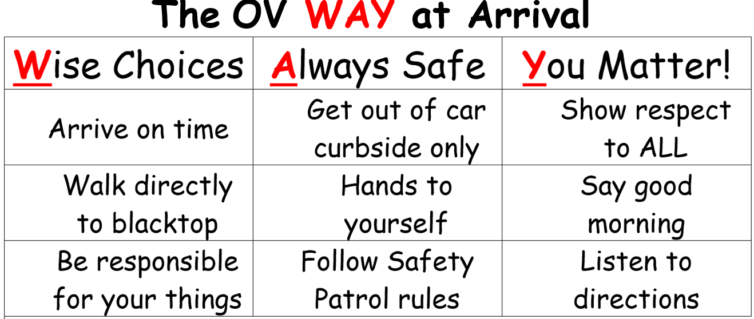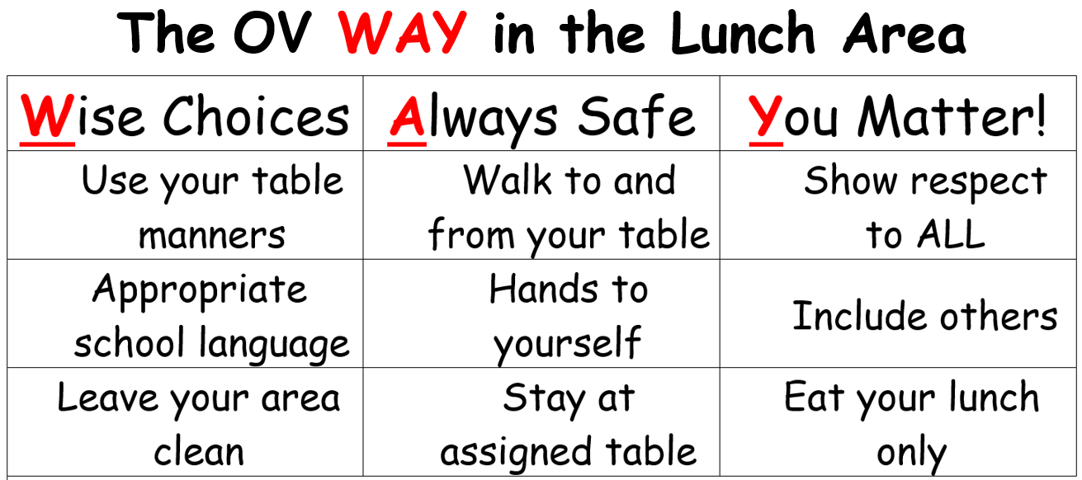

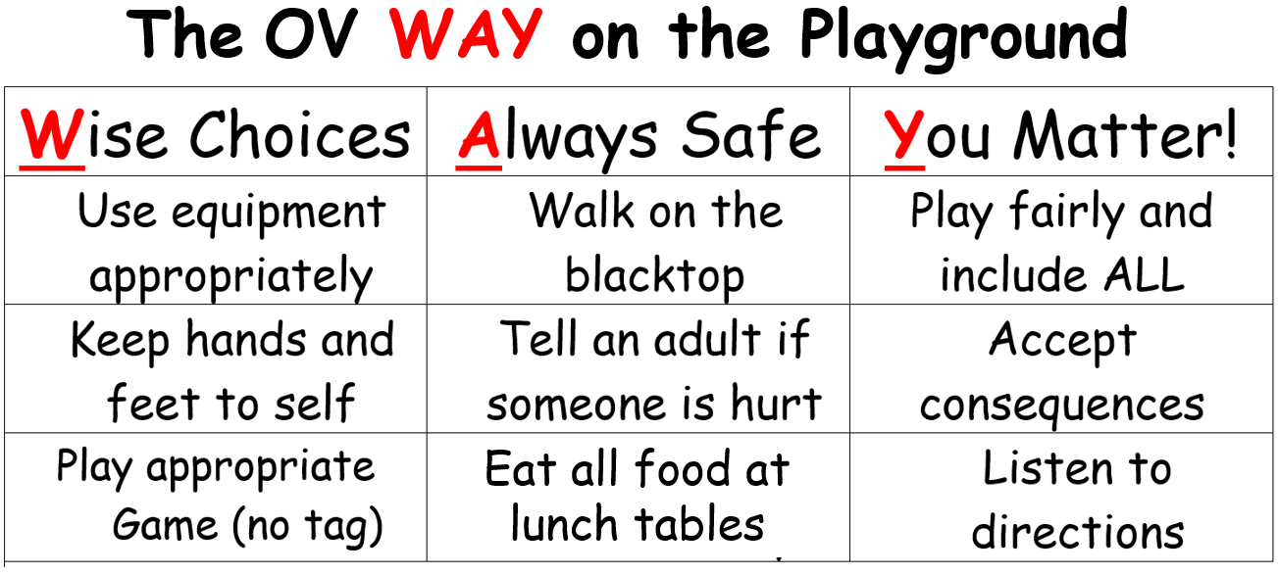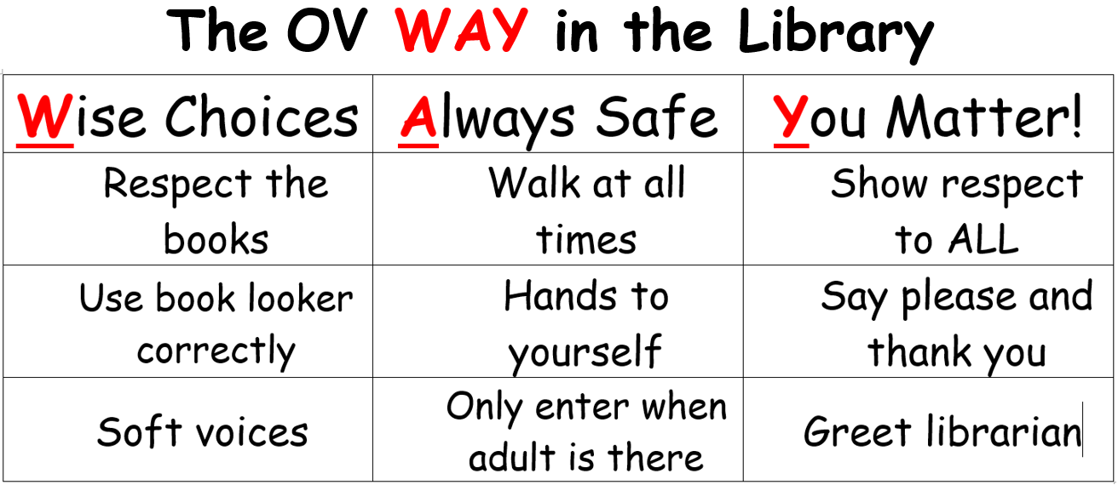

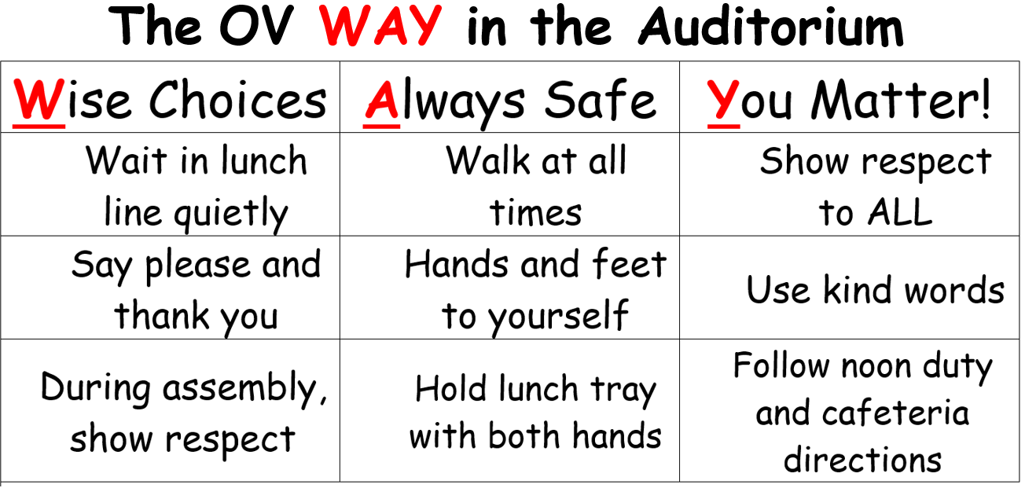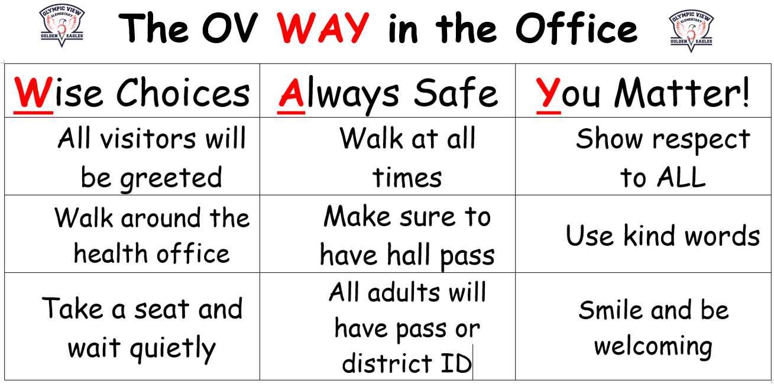

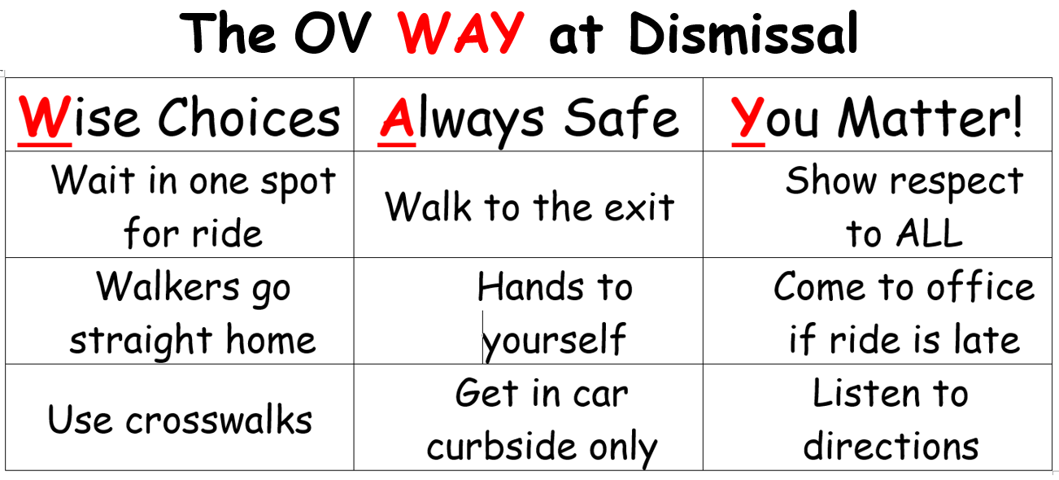

20

8 Habits and Character Strengths
Habit 1: Be Proactive (Initiative and Responsibility)

Habit 2: Begin with the End in Mind (Focus)

Habit 3: Put First Things First (Motivation)

Habit 4: Think Win-Win (Problem Solving)

Habit 5: Seek First to Understand, Then
Be Understood (Kindness and Respect)

Habit 6: Synergize (Teamwork)

Habit 7: Sharpen the Saw (Effort)

Habit 8: Find Your Voice (Perseverance and Honesty)

21

OLYMPIC VIEW STAFF 2026 – 2027

GRADE | NAME | E-MAIL ADDRESS
Principal | Mrs. Lisa Lines | lisa.lines@cvesd.org
Psychologist | Mrs. Manda Morris | manda.morris@cvesd.org
Nurse, RN | Mrs. Elizabeth Sharp | elizabeth.sharp@cvesd.org
School Secretary | Ms. Linda Wong | linda.wong@cvesd.org
AS/HS | Mrs. Shelley Acosta | shelley.acosta@cvesd.org
Preschool AM | Mrs. Ana Delgado | ana.delgado@cvesd.org
Preschool PM | Mrs. Martha “Gaby” Del Rio | martha.delrio@cvesd.org
Transitional Kinder | Mrs. Bessie Christian | bessie.christian@cvesd.org
Transitional Kinder | Mrs. Ana Garcia-Barr | ana.garciabarr@cvesd.org
Kindergarten | Mrs. Evette Contreras | evette.contreras@cvesd.org
Kindergarten | Ms. Sally Smith | sally.smith@cvesd.org
Kindergarten | Mrs. Cathy Manabat | catheri.celestialman@cvesd.org
First Grade | Mrs. Mary Ann Stenberg | maryann.stenberg@cvesd.org
First Grade | Ms. Gracie Gomez | gracie.gomez@cvesd.org
First Grade | Ms. Kim Foreman | kimberly.foreman@cvesd.org
Second Grade | Mrs. Chriezl Valerio | chriezl.valerio@cvesd.org
Second Grade | Mrs. Krishna Rivera | krishna.rivera@cvesd.org
Second Grade | Mrs. Ricki Goold | ricki.goold@cvesd.org
Third Grade | Mrs. Lisa Elkinton | lisa.elkinton@cvesd.org
Third Grade | Mrs. Jenn Viora | jennifer.viora@cvesd.org
Third Grade | Mrs. Odille Varcoe | odille.asuncionvarc@cvesd.org
Fourth Grade | Mrs. Raelene Salgado | stephanie.salgado@cvesd.org
Fourth Grade | Ms. Erin Pickett | erin.pickett@cvesd.org
Fourth/Fifth Grade Combo | Ms. Susan Barnard | susan.barnard@cvesd.org
Fifth Grade | Ms. Todd Gagielo | todd.gagielo@cvesd.org
Fifth Grade | Mrs. Pamela Abrose | pamela.ambrose@cvesd.org
Fifth/Sixth Grade Combo | Mrs. Pam Umali | pamela.umali@cvesd.org
Sixth Grade | Mrs. Kristin Baltierra | kristin.baltierra@cvesd.org
Sixth Grade | Ms. Cindy Tung | cynthia.tung@cvesd.org
Cafeteria Mgr. | Mrs. Evelyn Conriquez | evelyn.conriquez@cvesd.org
LEAD Site Lead (Clubs/LEAD HUB) | Mrs. Karla Velez | karla.velez@cvesd.org
LEP Aide | Mrs. Veronica Jimenez | veronica.jimenez@cvesd.org
Library Media Tech. | Mrs. Meliza Mesina | meliza.mesina@cvesd.org
Library Media Tech. | Mrs. Rhoda Murillo | rhoda.murillo@cvesd.org
RSP | Mrs. Gem Oca | gemjuvi.oca@cvesd.org
RSP | Ms. Noemi Talamante | noemi.talamante@cvesd.org

