How to attend a Teams Meeting
- From a web browser, go to the www.cvesd.org home page, and click ‘Students’
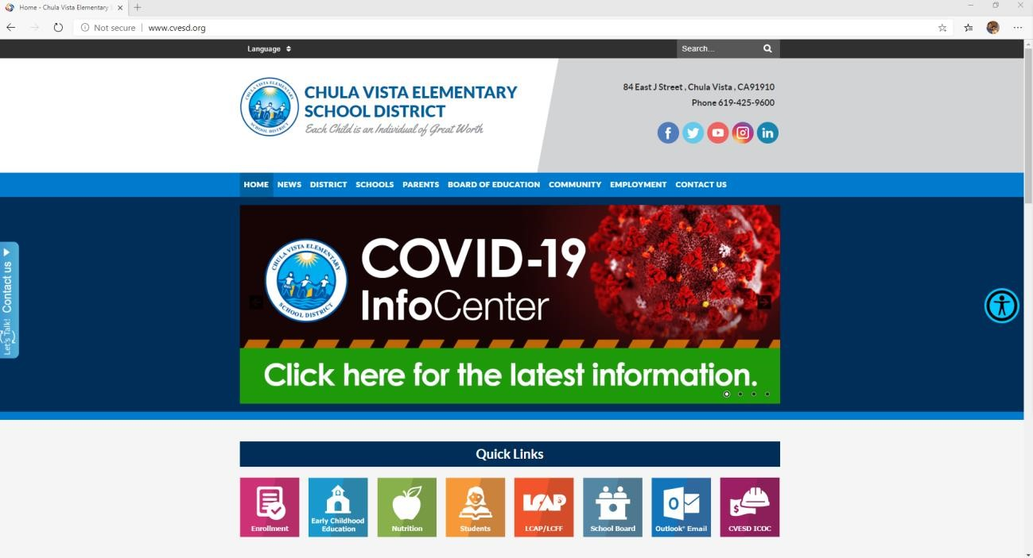

- On the Students page, click the ‘Office 365 Account Sign-in’ icon
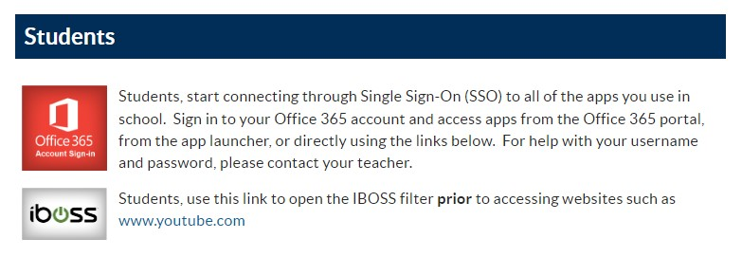
➢

- Click ‘Sign in’

Enter your child’s email address ######@live.cvesd.org and click ‘Next’

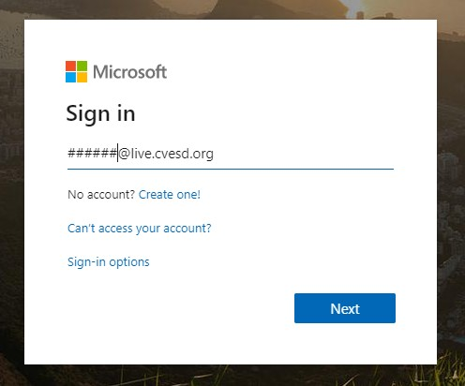

- Enter your child’s password and click ‘Sign in’

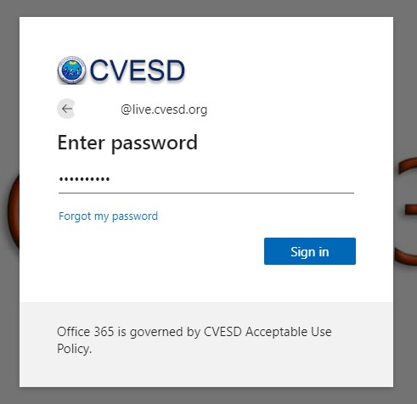

Click ‘Outlook’

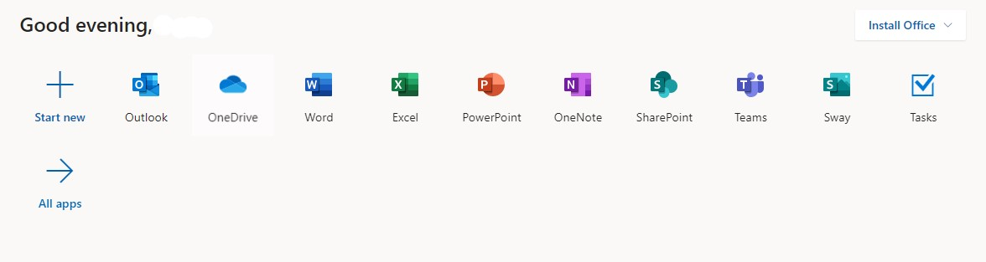

- In Outlook, click on the email from ‘User_Muraoka_Y20-50 02 121’ then click ‘Join Microsoft Teams Meeting’
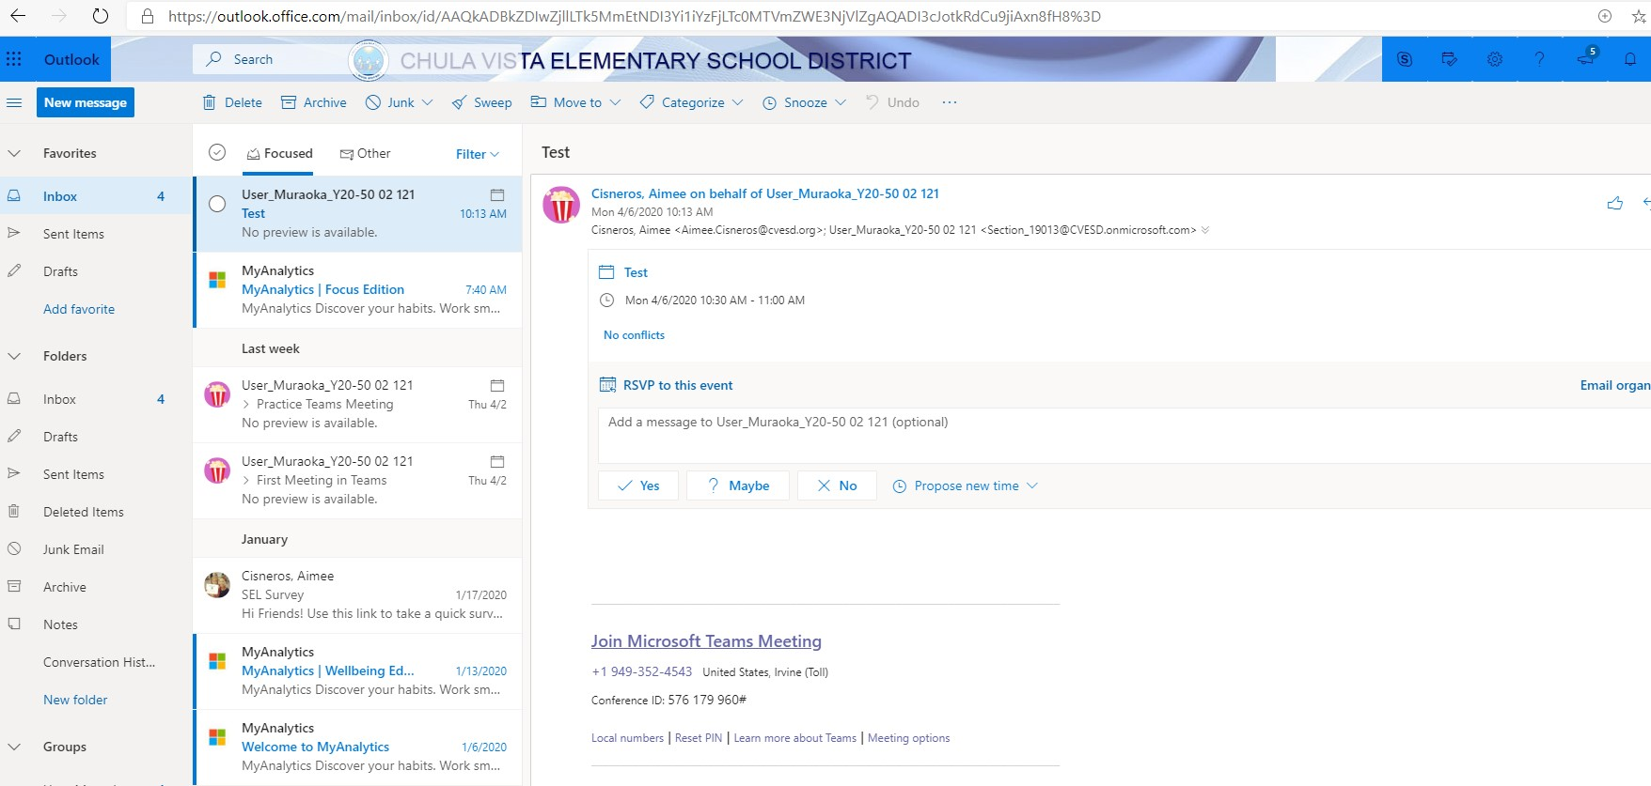
➢

If you have Microsoft Teams already installed on your computer you will receive a prompt stating “This site is trying to open Microsoft Teams” click Open
- If you do not have Microsoft Teams install on your computer, select ‘Continue on this browser’
