Chula Vista Elementary School District
Special Edition COVID-19 Newsletter Issue #7

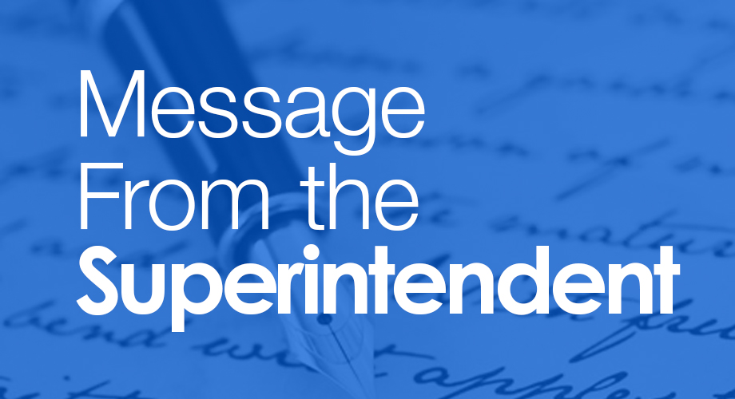

State Budget Proposal Would Devastate CVESD Schools
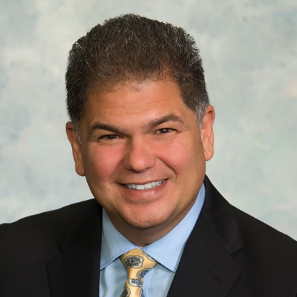
Dear Parents/Guardians and Staff Members:
As California begins reopening businesses in stages, we are already seeing the extraordinary negative economic impact of the COVID-19 shutdown on California. Governor Gavin Newsom recently released his revised proposal (known as the “May Revise”) for the 2020-21 state budget. In a word, the proposed budget cuts would be “devastating” to our schools as well as those across San Diego County and the state.
This is because Governor Newsom’s revised budget, if enacted, would mean a $6.5 billion cut to schools’ main source of funding. It would mean single-year reductions to public education worse than we experienced in the last recession. CVESD would experience a $24 million reduction in Local Control Funding Formula (LC FF) and Special Education revenues compared to what the District had been expecting from the governor’s January proposal for the 2020-21 fiscal year. Yes, it’s true—a $24 million switch in direction.
As we know, much has happened over the last couple of months that has changed our CVESD community and the world. CVESD is currently working with a broad group of stakeholders to develop a reopening plan for campuses. We anticipate the need to purchase everything from additional cleaning supplies to thermometers to thousands of face coverings/masks. This added expense comes at a time of the worst state budget gap and highest unemployment since the Great Depression.
The Board of Education and I will continue to dialogue with Congressional and Senate representatives to advocate for another round of federal stimulus funds. The new stimulus package is needed just for schools to survive. Nearly 90 percent of our District’s budget is in personnel costs, which is another way of saying “people.” With this level of budget reductions, we are looking at significant numbers of layoffs, furlough days, or both. If federal officials truly want to Celebrate Our Heroes, such as the recent Teacher Appreciation Week and Classified Employee Week, then they should do all they can to keep them employed.
As we watch how the federal stimulus debate plays out in Washington D.C., we will continue planning for various scenarios, both in how we reopen schools and what staff we will be able to have in place when we do reopen. Despite the serious fiscal challenges coming our way, we also will maintain focus on our primary purpose: educating students.
Guiding principles for decision-making in fiscal matters:
- Cutting as far away from the classroom as possible.
- As we continue to devise hybrid models of learning when students return to campuses, we need to prioritize having enough teachers in the classroom.
- Looking at all options to reduce the impact on services and staff (shortened work calendars, etc.)
- Focusing on the essential services—what do students need to succeed?
Balancing these important demands will not be easy. Many of the decisions that local school districts will be forced to undertake are directly related to the state budget and will be unpopular cuts. In the weeks and months ahead, we truly must be #InThisTogether, and unified in our purpose to weather these cuts.
My sincerest gratitude,
Francisco Escobedo, Ed.D.
Superintendent

Learn More



District’s Reserves Help Cushion the Impact of Economic Meltdown
If ever there was justification for our District’s prudent decision to set-aside sufficient and consistent reserves, this was it: a global pandemic. The financial havoc it has caused will be felt for years. Our Board of Education, and our leadership team stood fast on the need for saving funds for unanticipated emergencies. Now, our District’s 2019-20 estimated 13 percent in reserve funds is a key to getting us through this crisis. We will be able to physically reopen CVESD campuses in the new school year. Other school districts may have spent down their reserves below levels recommended by state finance officials. This may impact their ability to resume operations in the way that our District is planning and preparing to do.

Families Receive WiFi Hotspots,
Thanks to City of Chula Vista Partnership
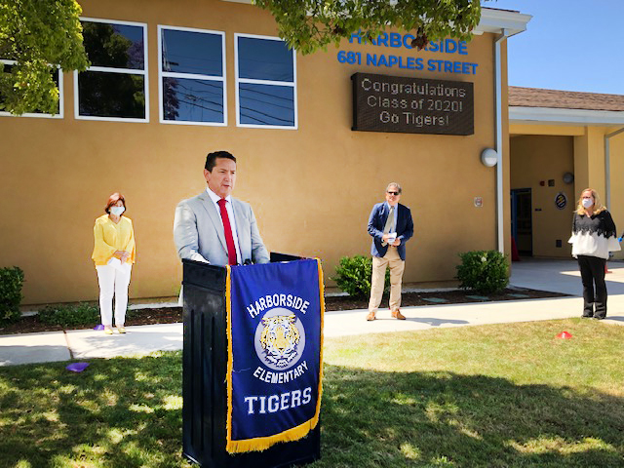
To assist our neediest students with online learning, our District partnered with the City of Chula Vista to expand broadband access. The Chula Vista City Council voted unanimously to an agreement with T-Mobile and potentially other telecommunication providers to purchase 2,000 WiFi hotspots. Funding totaling $650,000 is being paid for by the city’s Public, Educational, Governmental funding, not its general fund. CVESD is paying the $20,000 monthly service costs. Last week, WiFi hotspots were distributed to foster youth, homeless youth, Special Education students and other CVESD families who might not otherwise afford broadband access. The partner agencies held a joint press conference at Harborside Elementary to highlight their work together.

Learn More

We Need Your Input: Parent Survey on Distance Learning Plan and School Reopening
With the current school year winding down under distance learning, plans for the next school year are being developed with a number of possible reopening plans under consideration. We understand that every family has a unique situation, whether health status, or comfort level in regard to reopening campuses. This brief, but important survey will help guide us as we consider staffing needs and models for teaching whether physically in person in a classroom, online in a virtual classroom, or a combination of both. The purpose of this survey is to measure your experience and the experience of your child(ren) this 2019-20 academic year, and to assist schools in planning for the 2020-21 school year. Parents/guardians of current students will also be asked about interest in continuing their student's education in CVESD for grades 7 and 8. The survey takes just a few minutes. Thank you in advance for your assistance.

Take Survey

YouTube Videos

  
  Robyn Lee Elsmore
  The grade 5 teacher at Camarena Elementary has made the transition to distance teaching. The 23-year veteran and District Teacher of the Year credits the collaboration with her grade-level teammates in helping her utilize multiple digital platforms to connect with students.
  Watch Video

  Meg Rabine
  This former District Teacher of the Year admits it took her awhile to adjust to distance teaching, but the Clear View Elementary educator has created a successful model for others to emulate. Her advice to parents: Allow your kids to explore what they are interested in and help them to try and find the gratitude in the present situation.
  Watch Video
  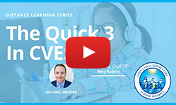

  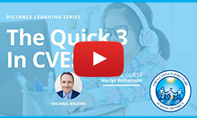
  Marlys Willamson
  A current District Teacher of the Year, this Wolf Canyon Elementary teacher offers two live virtual lessons each day to assist students in math. Willamson also aids students with their social emotional learning through small group and whole class discussions.
  Watch Video

© Chula Vista Elementary School District
Have thoughts about the newsletter? Send us any questions or comments using Let’s Talk!

