
Incoming 7th Grade

Registration Nights

Welcome incoming 7th graders to Eastlake Middle School.
In an effort to make your first experience with us as enjoyable as possible, we have made a few changes to the registration process. You MUST complete the online registration for Sweetwater Union High School District, prior to enrolling at Eastlake Middle. Activation codes were mailed to all incoming sixth grade families. If you did not receive your activation code, please call us so we may assist you prior to registration night(s). 619-591-4000.

Directions for completing your online registration can be found at our website:
http://elm.sweetwaterschools.org/registration20192020/

Once you have completed your online registration, please feel free to sign up for an appointment time at the following: http://elm.sweetwaterschools.org/registration20192020/
We cannot register your student if their immunizations are not up to date.
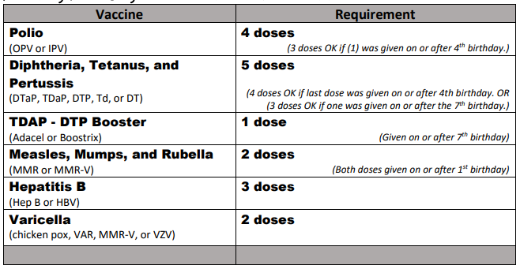

Registration Nights:
Final Night: April 25: 4-6 pm
School Hours by Appointment: M-Th (9:00 – 12:00), F (1:00 – 3:30)

