

OLYMPIC VIEW SOCCER SCHEDULE

CHULA VISTA ELEMENTARY SCHOOL DISTRICT
2019 CO-ED SOCCER LEAGUE (Division I)

All games listed are THURSDAYS from 4:00 – 5:00 pm

Date
Thurs. Feb. 28 Home vs Salt Creek
Thurs. March 7 Home vs Heritage
Thurs. March 14 Home vs Silver Wing
Thurs. March 21 Home vs Valley Vista
Thurs. April 11 Away at Veterans
WED April 17 Away at Discovery
Thurs. April 18 Home vs Camarena
WED. April 24 Away at CVLCC
Thurs. April 25 Away at Casillas
Thurs. May 2 HOME vs Arroyo Vista

Possible Playoffs:
Semifinals for teams ranked #1 through #4: Thurs. May 9
Championship Game: Week of May 13-17 TBD



CO-ED BASKETBALL LEAGUE - OLYMPIC VIEW SCHEDULE

CHULA VISTA ELEMENTARY SCHOOL DISTRICT

Most games are played on THURSDAYS at 4:00pm

Date Opponent Location
1/24/19 Halecrest HOME
1/31/19 - Rain Otay HOME 2/07/19 Allen Allen
2/14/19- Rain Heritage Heritage
2/21/19 - Rain Hilltop HOME
2/25/19 - Monday Heritage Heritage
2/28/19 Parkview HOME
3/06/19 - Wednesday Heritage HOME
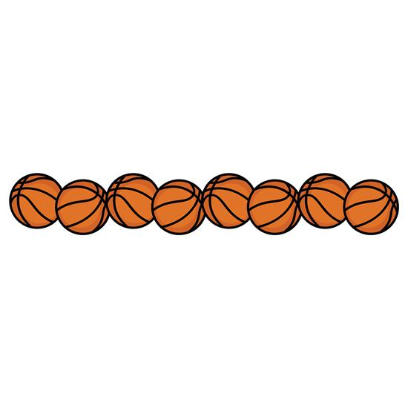
3/07/19 -Thursday Hilltop Hilltop
3/08/19 – Friday Hilltop HOME
3/14/19 Parkview Parkview
3/20/19 - Wednesday Otay HOME
3/22/19 Championship Game Parkview Gym

